grid_1_res_Automatic_NS

{'max_leaf_nodes': 64, 'n_estimators': 800}

{'C': 0.001, 'penalty': 'none'}

{'C': 100, 'gamma': 100}

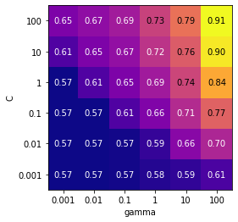

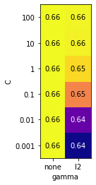

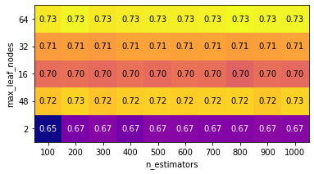

SVM rbf

R^2: 0.7868663594470046

recall_score: 0.7868663594470046

f1_score: 0.7868663594470046

accuracy_score: 0.7868663594470046

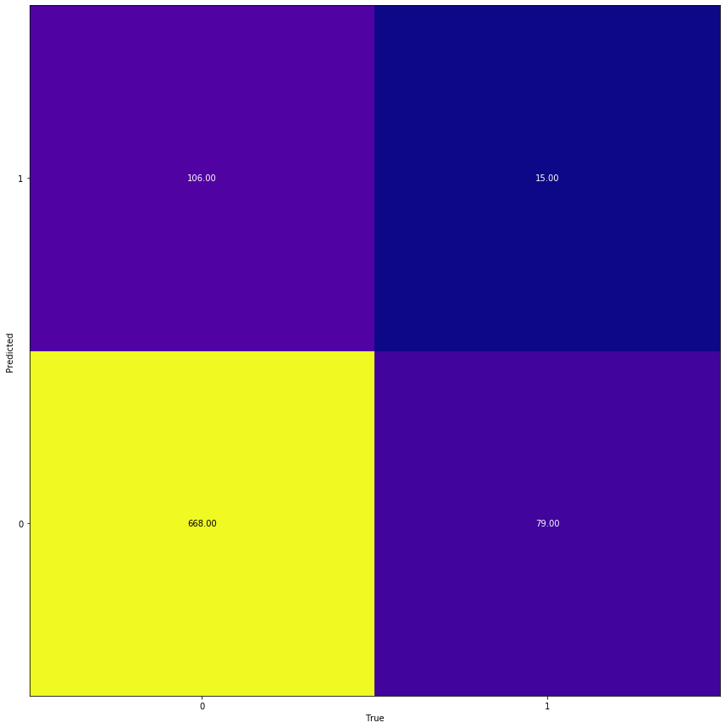

LogReg

R^2: 0.5622119815668203

recall_score: 0.5622119815668203

f1_score: 0.5622119815668203

accuracy_score: 0.5622119815668203

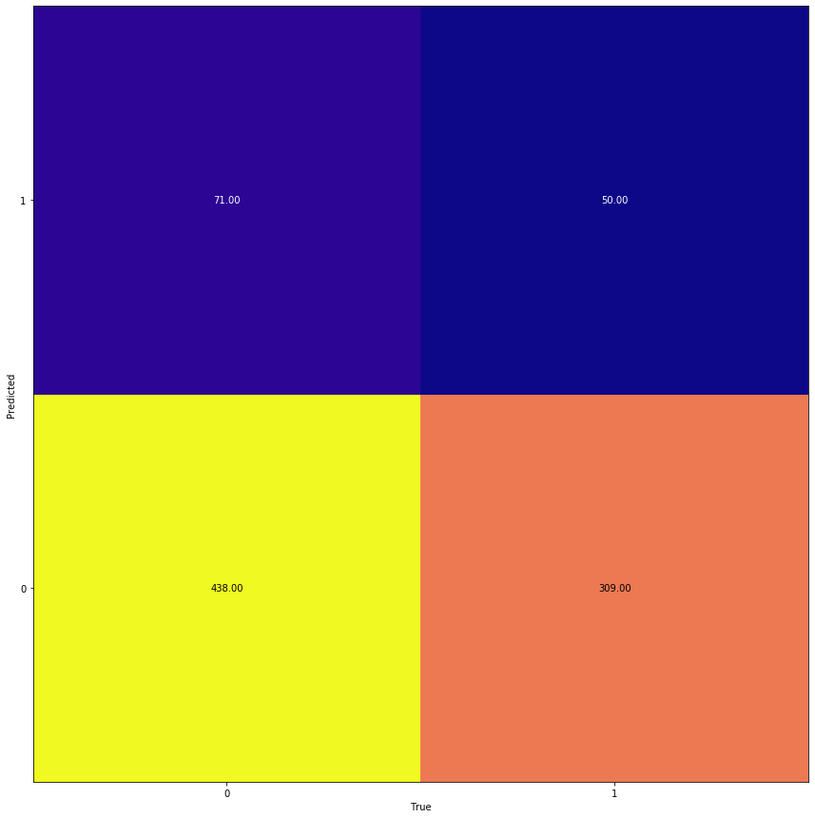

RND

R^2: 0.6071428571428571

recall_score: 0.6071428571428571

f1_score: 0.6071428571428571

accuracy_score: 0.6071428571428571

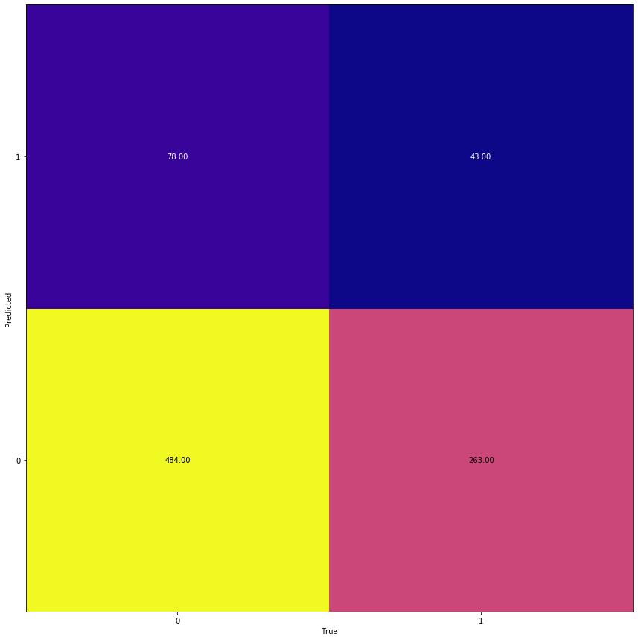

grid_1_res_Automatic_IE

{'C': 100, 'gamma': 100}

{'C': 1, 'penalty': 'l2'}

{'max_leaf_nodes': 64, 'n_estimators': 800}

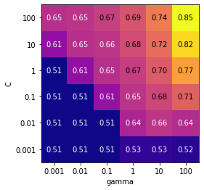

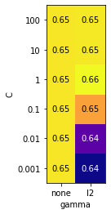

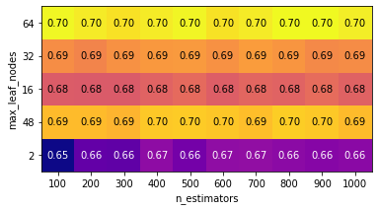

SVM rbf

R^2: 0.7119815668202765

recall_score: 0.7119815668202765

f1_score: 0.7119815668202765

accuracy_score: 0.7119815668202765

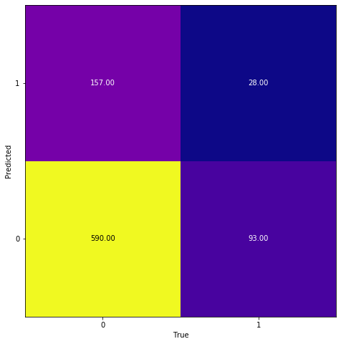

LogReg

R^2: 0.5449308755760369

recall_score: 0.5449308755760369

f1_score: 0.5449308755760369

accuracy_score: 0.5449308755760369

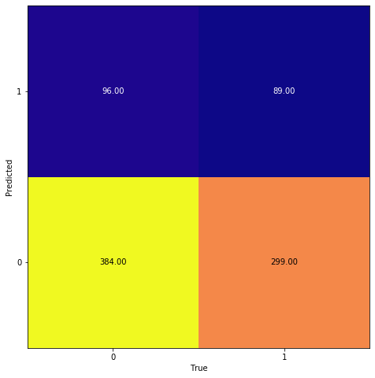

RND

R^2: 0.6209677419354839

recall_score: 0.6209677419354839

f1_score: 0.6209677419354839

accuracy_score: 0.6209677419354839

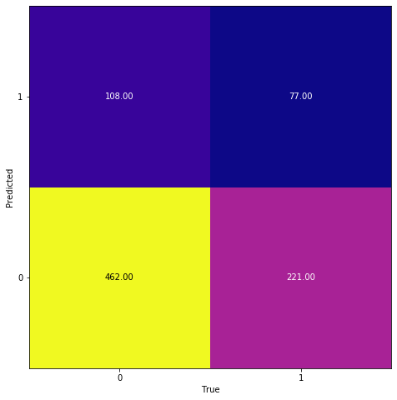

grid_1_res_Automatic_TF

{'C': 10, 'gamma': 10}

{'C': 0.001, 'penalty': 'none'}

{'max_leaf_nodes': 64, 'n_estimators': 100}

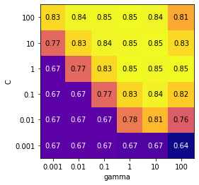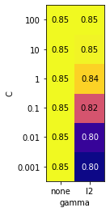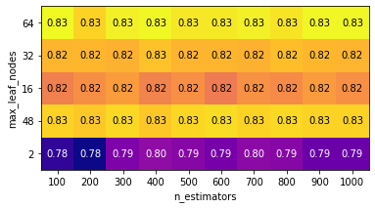

SVM rbf

R^2: 0.47235023041474655

recall_score: 0.47235023041474655

f1_score: 0.4723502304147465

accuracy_score: 0.47235023041474655

LogReg

R^2: 0.4308755760368664

recall_score: 0.4308755760368664

f1_score: 0.4308755760368664

accuracy_score: 0.4308755760368664

RND

R^2: 0.46543778801843316

recall_score: 0.46543778801843316

f1_score: 0.46543778801843316

accuracy_score: 0.46543778801843316

**grid_1_res_Automatic_JP**

{'C': 100, 'gamma': 100}

{'C': 0.001, 'penalty': 'none'}

{'max_leaf_nodes': 64, 'n_estimators': 1000}

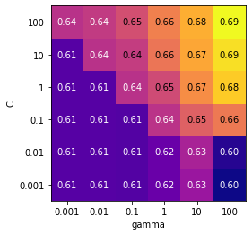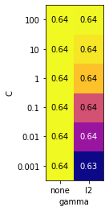

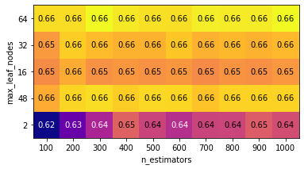

SVM rbf

R^2: 0.5172811059907834

recall_score: 0.5172811059907834

f1_score: 0.5172811059907834

accuracy_score: 0.5172811059907834

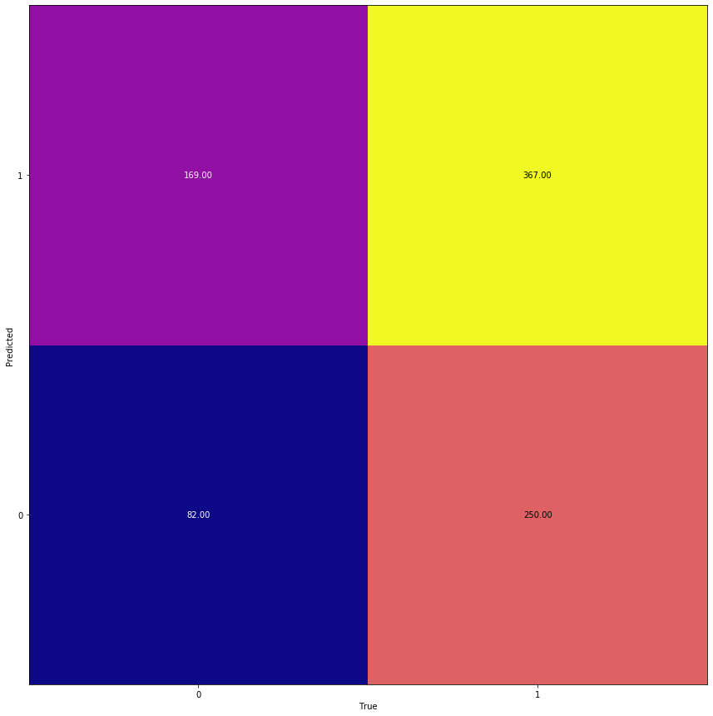

LogReg

R^2: 0.3617511520737327

recall_score: 0.3617511520737327

f1_score: 0.3617511520737327

accuracy_score: 0.3617511520737327

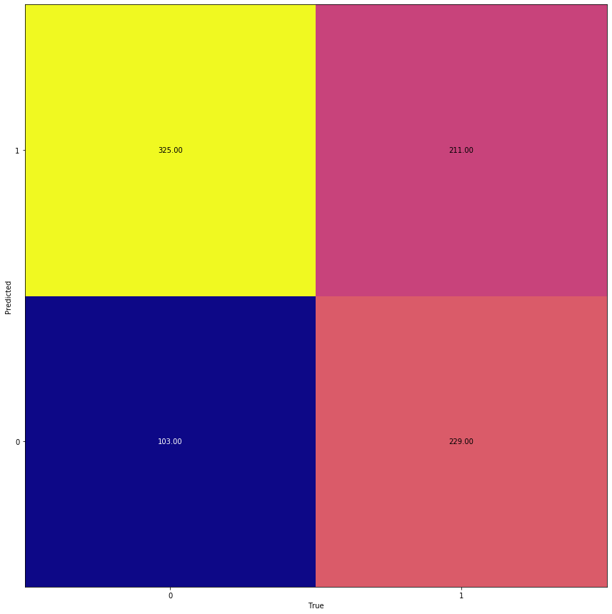

RND

R^2: 0.3870967741935484

recall_score: 0.3870967741935484

f1_score: 0.3870967741935484

accuracy_score: 0.3870967741935484

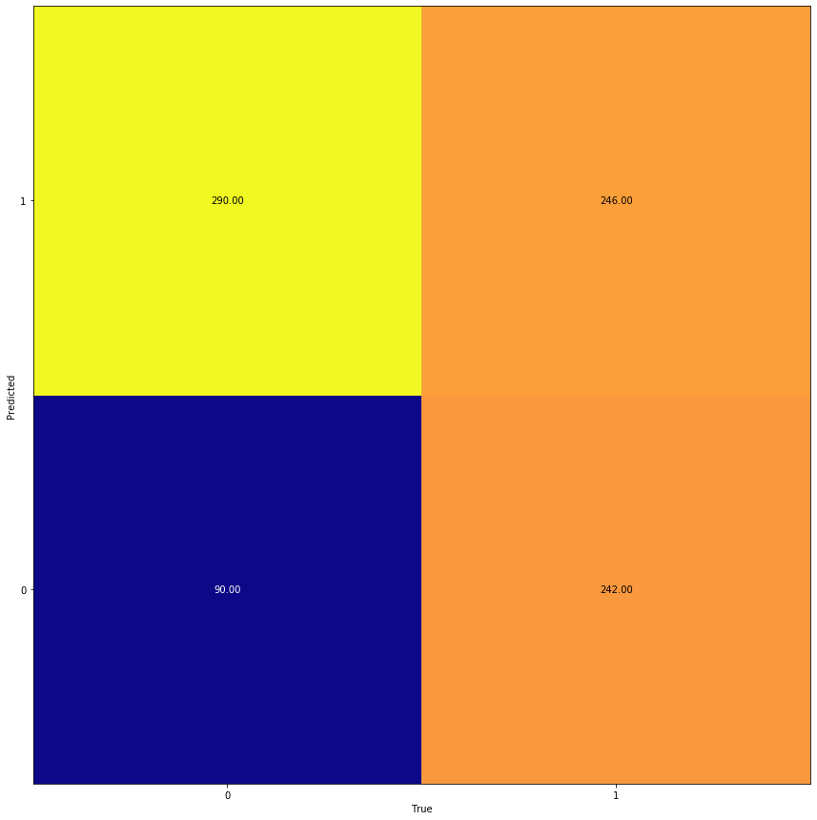

PCA

Resampling normalnie 2

{'C': 100, 'penalty': 'l2'}

{'max_leaf_nodes': 64, 'n_estimators': 400}

LogReg

R^2: 0.04953917050691244

recall_score: 0.04953917050691244

f1_score: 0.04953917050691244

accuracy_score: 0.04953917050691244

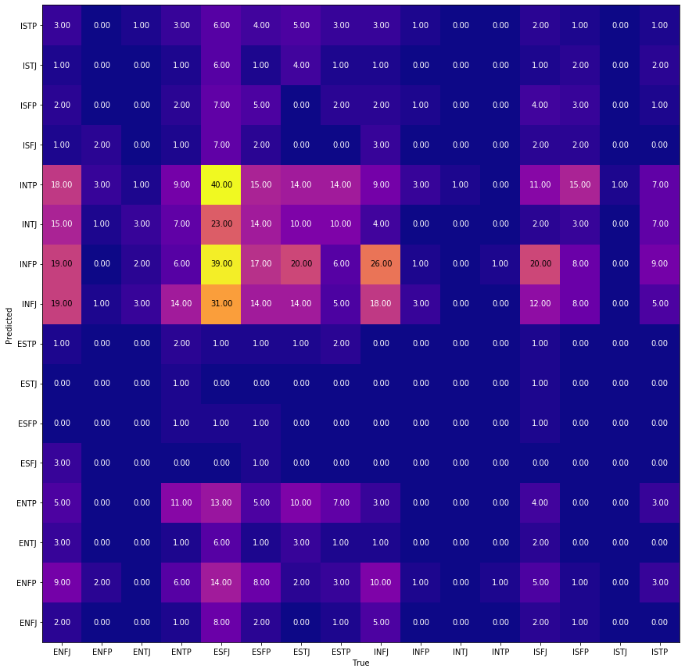

RND

R^2: 0.08064516129032258

recall_score: 0.08064516129032258

f1_score: 0.08064516129032258

accuracy_score: 0.08064516129032258

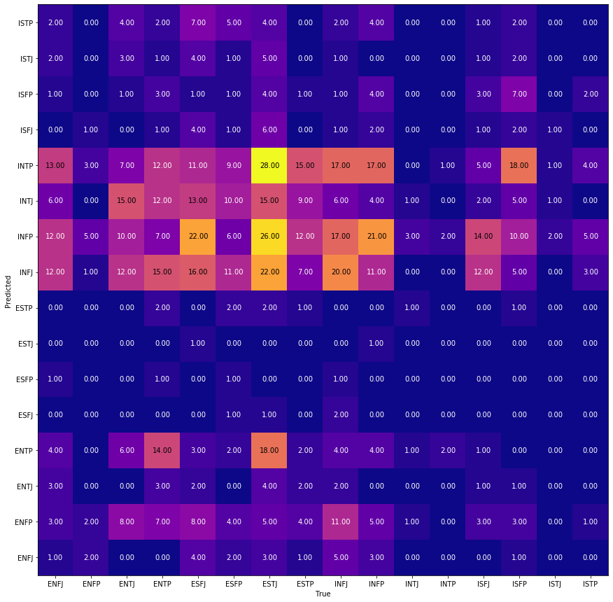

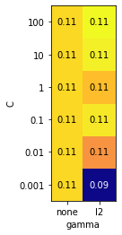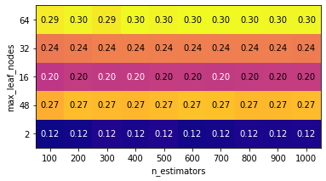

grid_2_res_normal_IE

{'C': 10, 'penalty': 'l2'}

{'max_leaf_nodes': 64, 'n_estimators': 200}

In [26]:

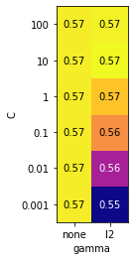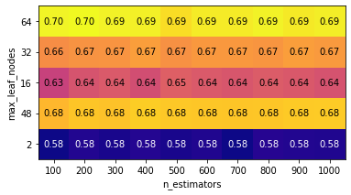

LogReg

R^2: 0.5126728110599078

recall_score: 0.5126728110599078

f1_score: 0.5126728110599078

accuracy_score: 0.5126728110599078

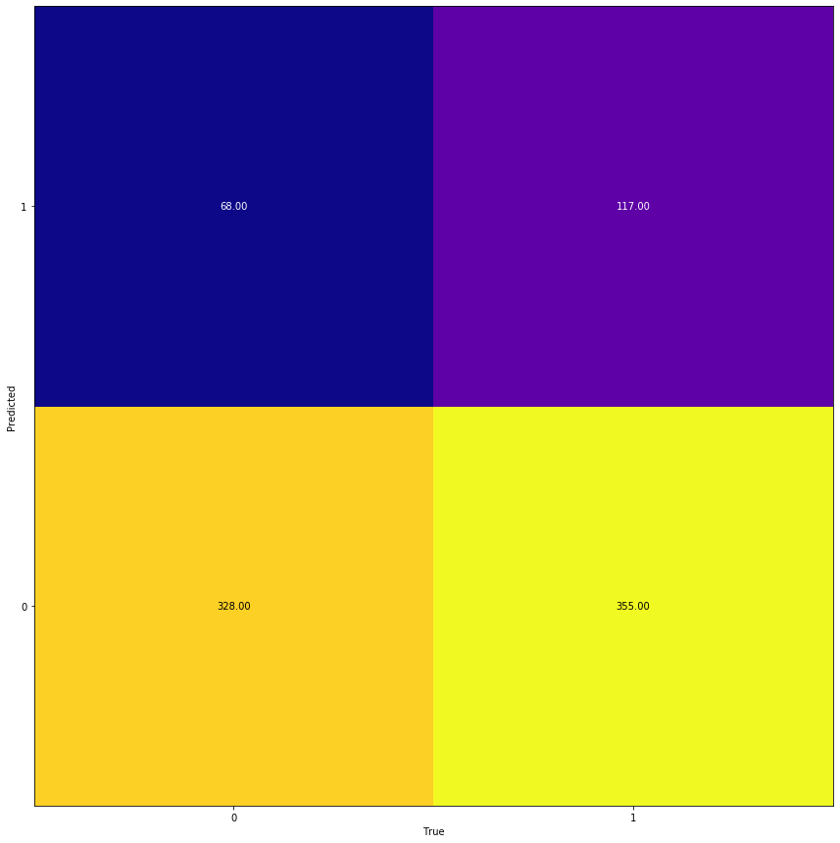

RND

R^2: 0.6370967741935484

recall_score: 0.6370967741935484

f1_score: 0.6370967741935484

accuracy_score: 0.6370967741935484

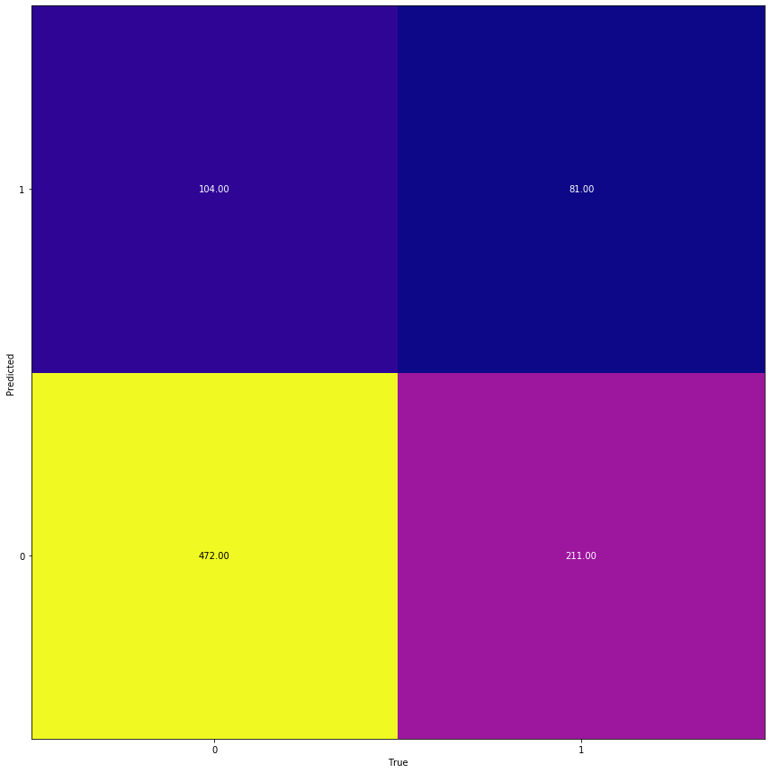

grid_2_res_normal_NS

{'C': 10, 'penalty': 'l2'}

{'max_leaf_nodes': 64, 'n_estimators': 1000}

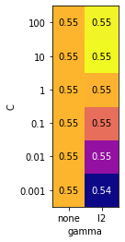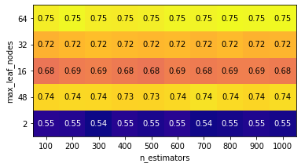

LogReg

R^2: 0.5368663594470046

recall_score: 0.5368663594470046

f1_score: 0.5368663594470046

accuracy_score: 0.5368663594470046

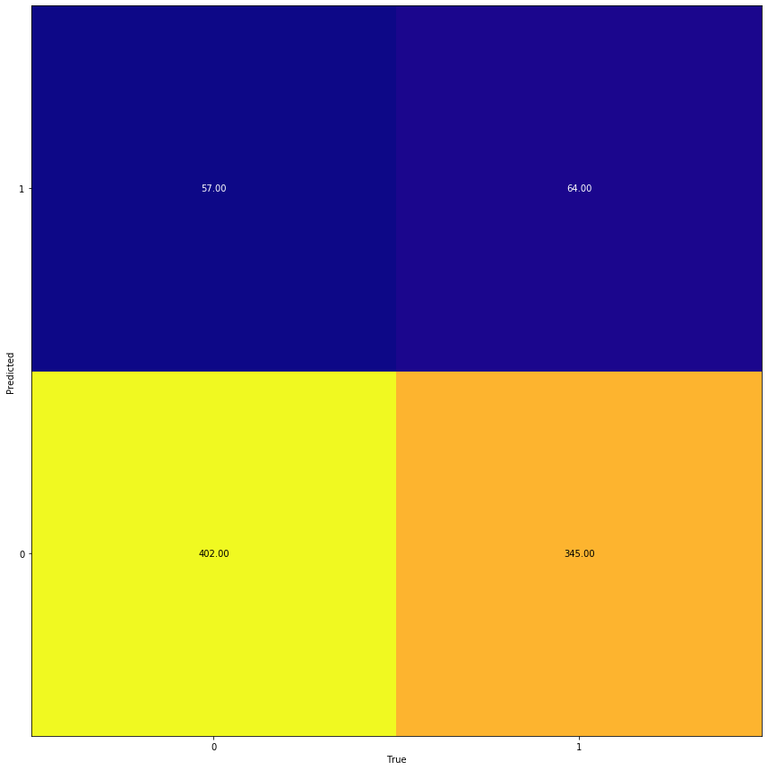

RND

R^2: 0.7327188940092166

recall_score: 0.7327188940092166

f1_score: 0.7327188940092166

accuracy_score: 0.7327188940092166

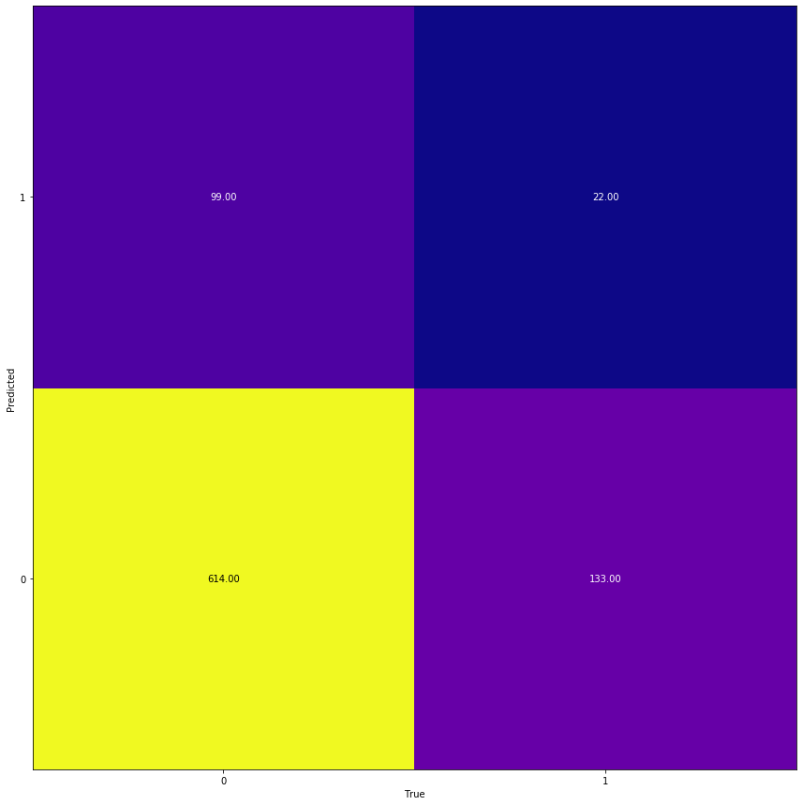

grid_2_res_normal_TF

{'C': 10, 'penalty': 'l2'}

{'max_leaf_nodes': 64, 'n_estimators': 900}

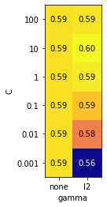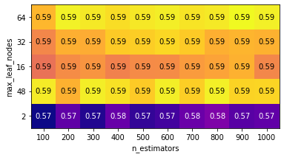

LogReg

R^2: 0.5956221198156681

recall_score: 0.5956221198156681

f1_score: 0.5956221198156681

accuracy_score: 0.5956221198156681

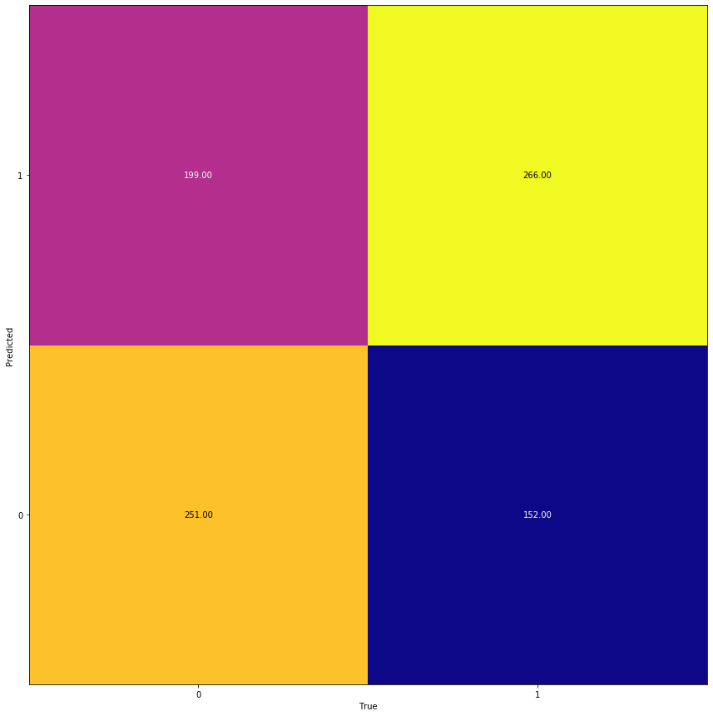

RND

R^2: 0.5829493087557603

recall_score: 0.5829493087557603

f1_score: 0.5829493087557603

accuracy_score: 0.5829493087557603

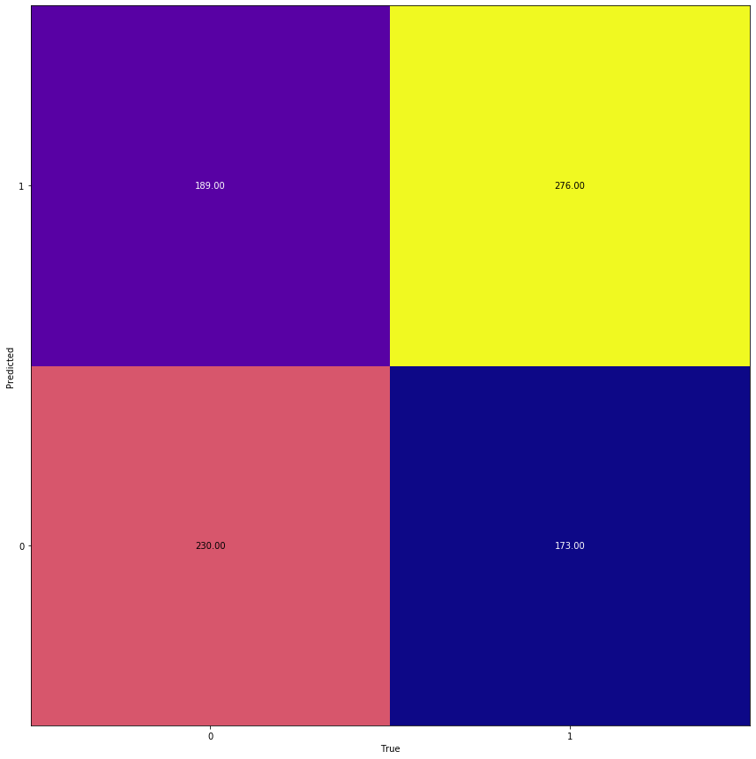

grid_2_res_normal_JP

{'C': 1, 'penalty': 'l2'}

{'max_leaf_nodes': 64, 'n_estimators': 600}

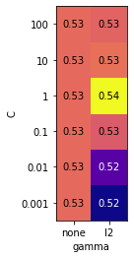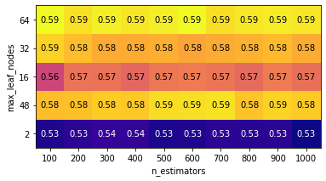

LogReg

R^2: 0.532258064516129

recall_score: 0.532258064516129

f1_score: 0.532258064516129

accuracy_score: 0.532258064516129

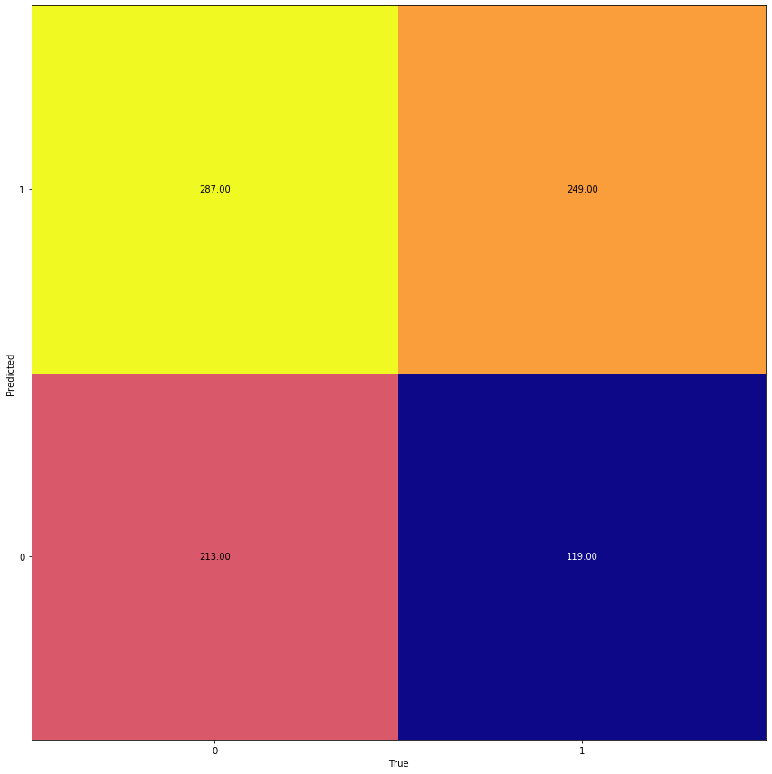

RND

R^2: 0.5610599078341014

recall_score: 0.5610599078341014

f1_score: 0.5610599078341014

accuracy_score: 0.5610599078341014

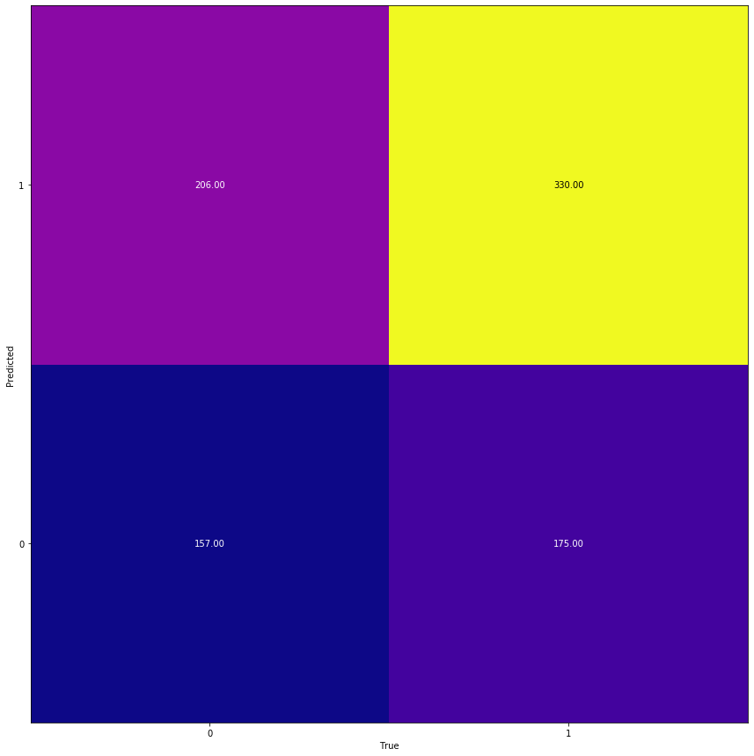

PCA

Resampling normalnie PCA

{'C': 1, 'penalty': 'l2'}

{'max_leaf_nodes': 64, 'n_estimators': 1000}

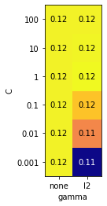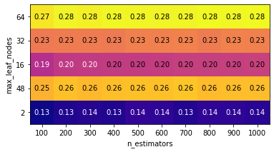

LogReg

R^2: 0.06797235023041474

recall_score: 0.06797235023041474

f1_score: 0.06797235023041474

accuracy_score: 0.06797235023041474

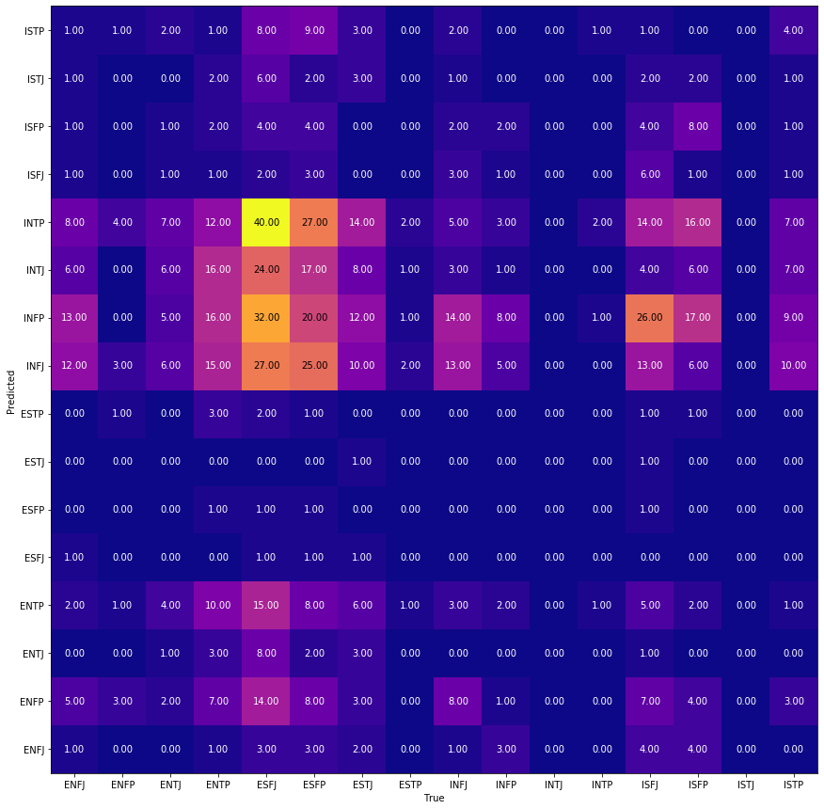

RND

R^2: 0.056451612903225805

recall_score: 0.056451612903225805

f1_score: 0.056451612903225805

accuracy_score: 0.056451612903225805

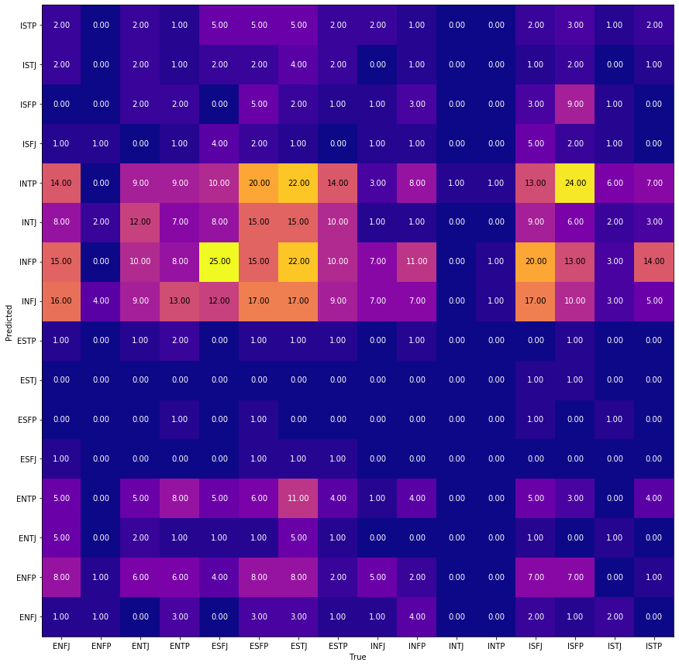

grid_2_res_normal_IE_PCA

{'C': 0.001, 'penalty': 'l2'}

{'max_leaf_nodes': 64, 'n_estimators': 900}

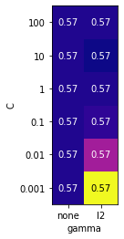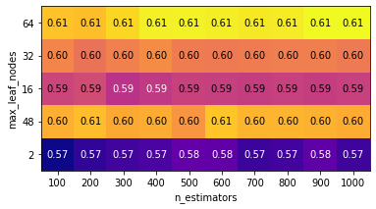

LogReg

R^2: 0.5023041474654378

recall_score: 0.5023041474654378

f1_score: 0.5023041474654378

accuracy_score: 0.5023041474654378

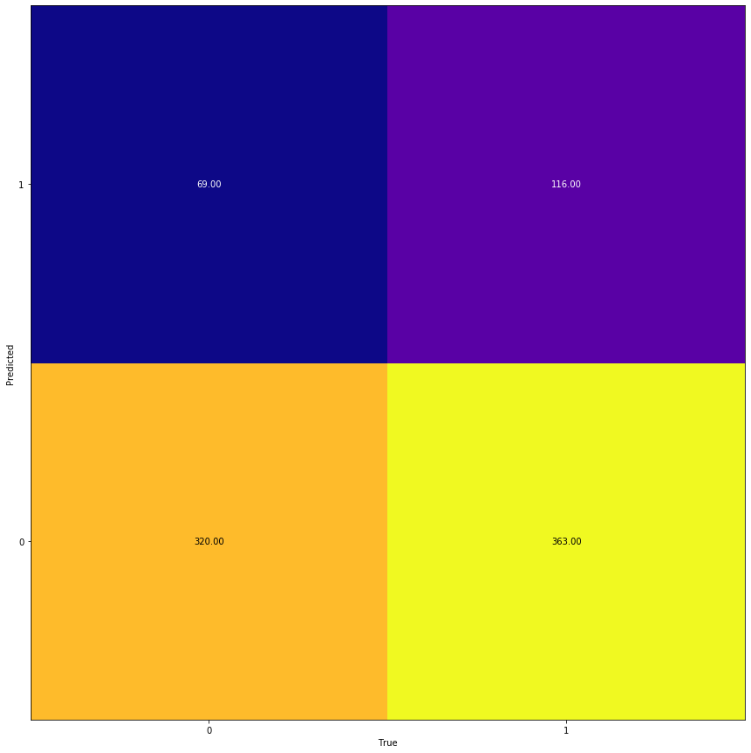

RND

R^2: 0.4792626728110599

recall_score: 0.4792626728110599

f1_score: 0.4792626728110599

accuracy_score: 0.4792626728110599

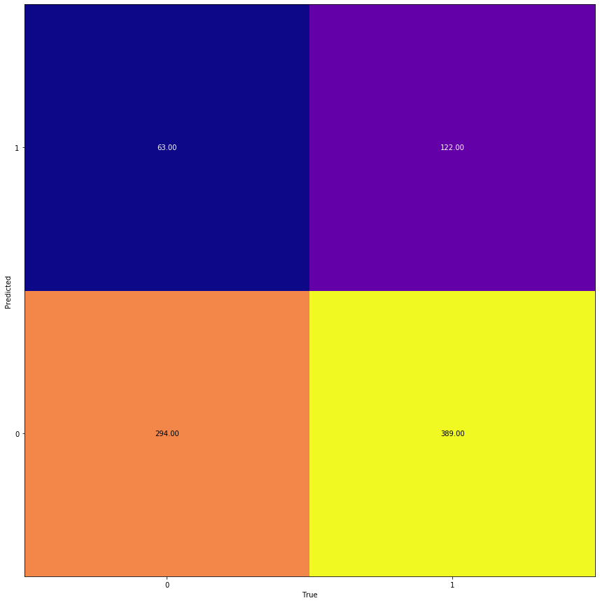

grid_2_res_normal_NS_PCA

{'C': 0.01, 'penalty': 'l2'}

{'max_leaf_nodes': 64, 'n_estimators': 200}

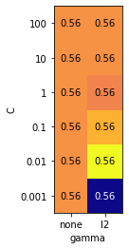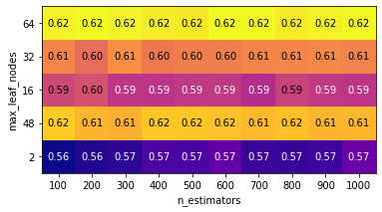

LogReg

R^2: 0.5138248847926268

recall_score: 0.5138248847926268

f1_score: 0.5138248847926268

accuracy_score: 0.5138248847926268

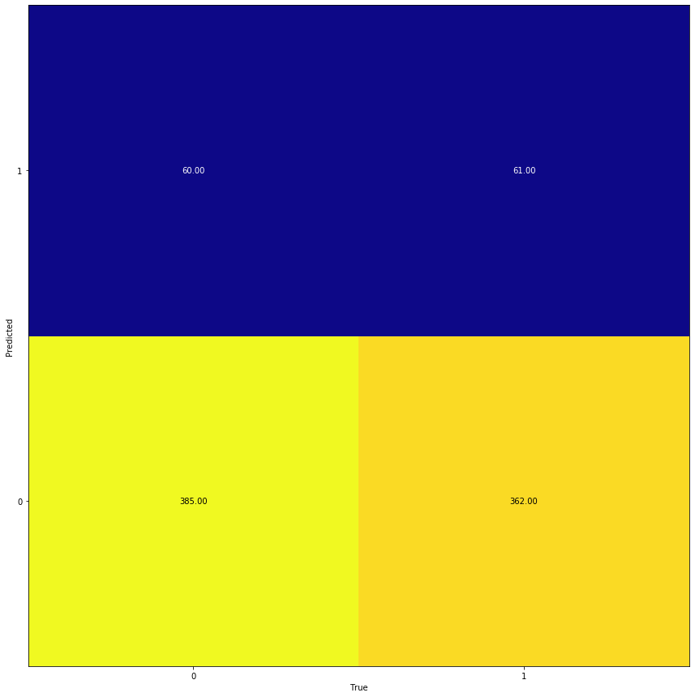

RND

R^2: 0.48963133640552997

recall_score: 0.48963133640552997

f1_score: 0.48963133640552997

accuracy_score: 0.48963133640552997

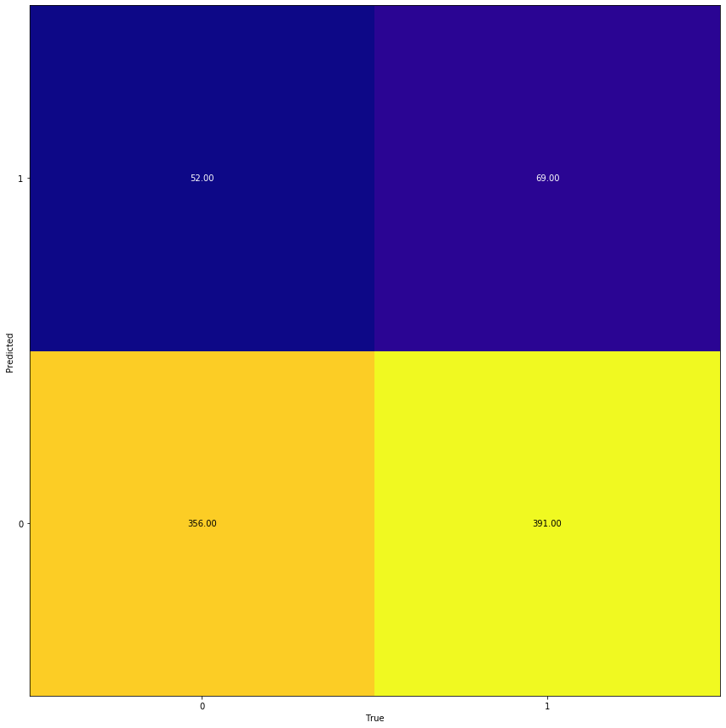

grid_2_res_normal_TF-PCA

{'C': 0.01, 'penalty': 'l2'}

{'max_leaf_nodes': 48, 'n_estimators': 100}

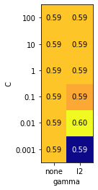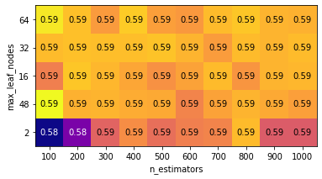

LogReg

R^2: 0.5933179723502304

recall_score: 0.5933179723502304

f1_score: 0.5933179723502304

accuracy_score: 0.5933179723502304

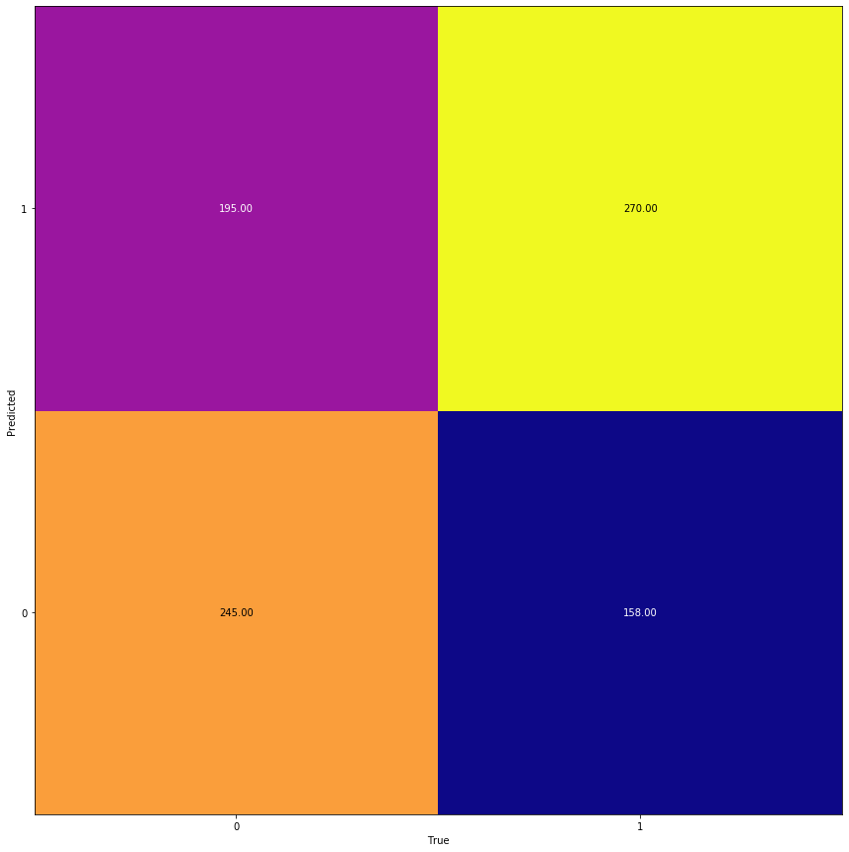

RND

R^2: 0.5887096774193549

recall_score: 0.5887096774193549

f1_score: 0.5887096774193549

accuracy_score: 0.5887096774193549

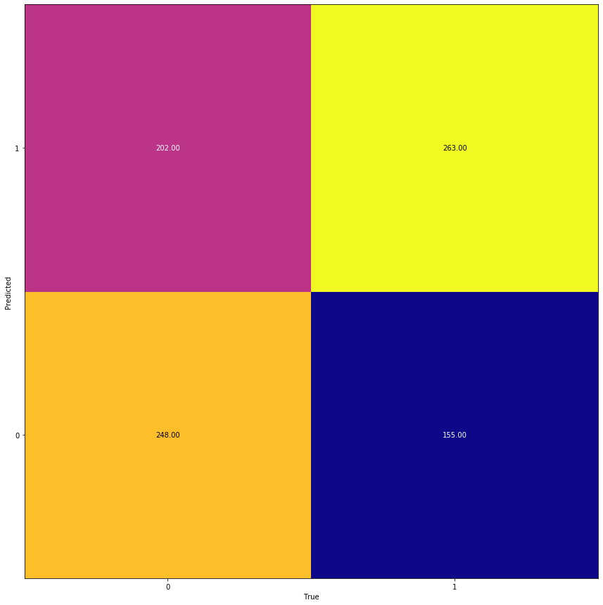

grid_2_res_normal_JP_PCA

{'C': 0.001, 'penalty': 'l2'}

{'max_leaf_nodes': 64, 'n_estimators': 700}

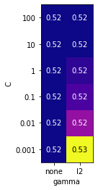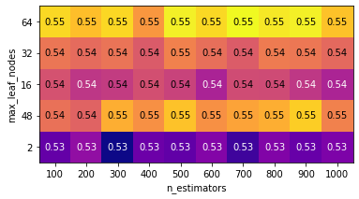

LogReg

R^2: 0.521889400921659

recall_score: 0.521889400921659

f1_score: 0.521889400921659

accuracy_score: 0.521889400921659

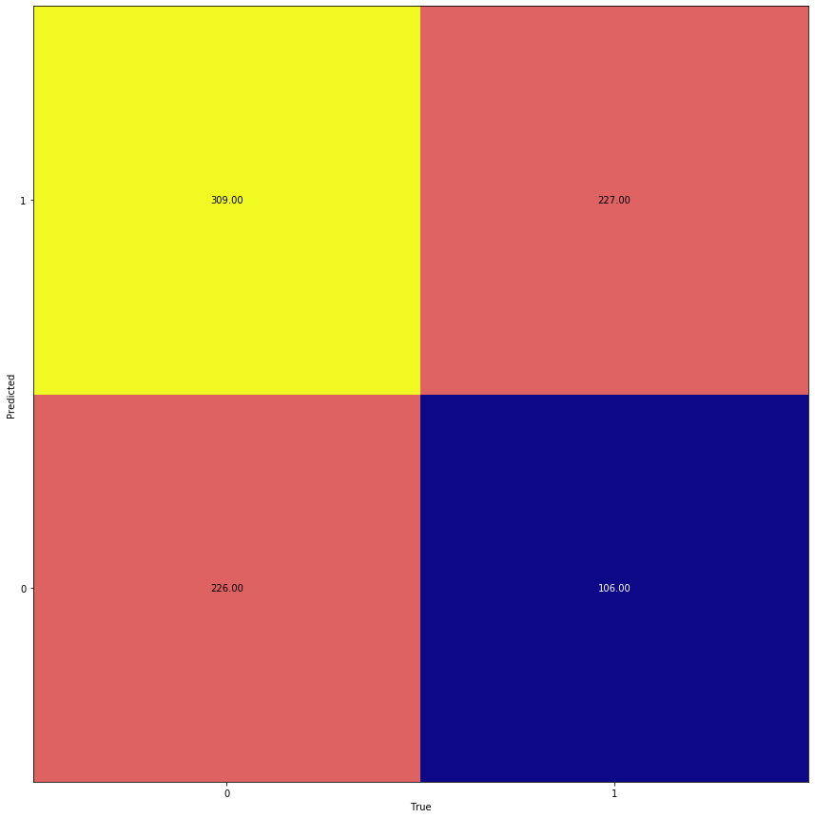

RND

R^2: 0.5126728110599078

recall_score: 0.5126728110599078

f1_score: 0.5126728110599078

accuracy_score: 0.5126728110599078

